**DATABASE imdb_small**

**Relational model**:

ACTORS (id, first_name, last_name, gender)

DIRECTORS (id, first_name, last_name)

MOVIES (id, name, year, rank)

MOVIES_DIRECTORS (director_id*, movie_id*)

MOVIES_GENRES (movie_id*, genre)

ROLES (actor_id*, movie_id*, role)

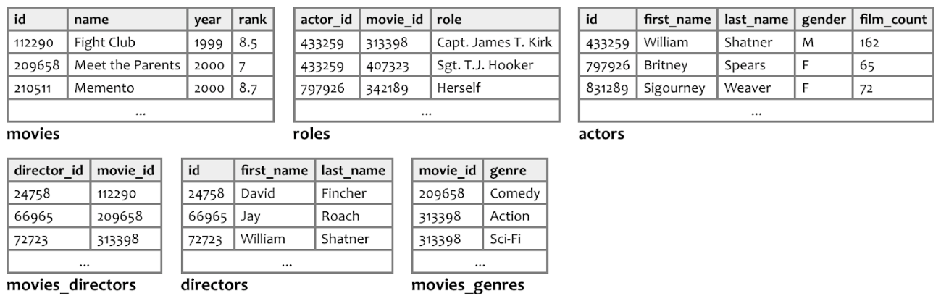

Link to download the database [here](https://drive.google.com/file/d/1ApTJA3mS_tfFwTreFGMExu3ZdvOMpyDx/view?usp=sharing).

NOTES:

* I would create a table for genres…
* The exercises are not sorted by order of difficulty...

**1.-** Data of all the actors with the surname 'Willis'.

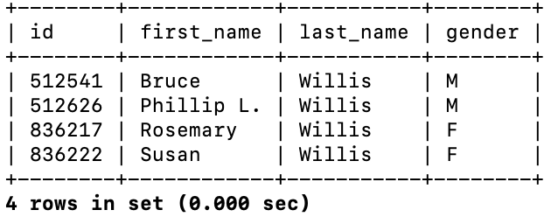

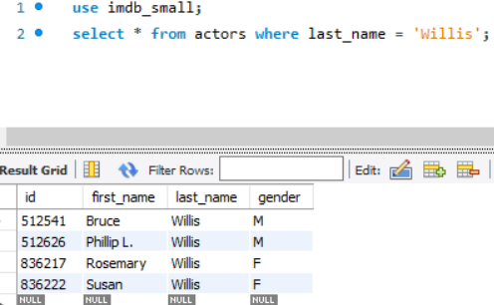

2. Code and title of the movies that in its title there are some of the following words: "kill", "pirates", "war", "man". Order the result by movie title.

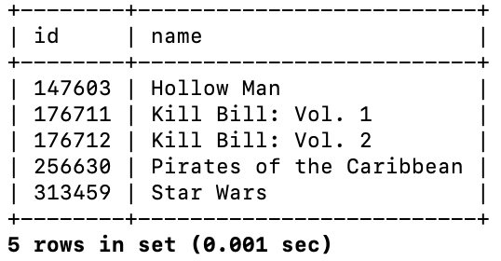

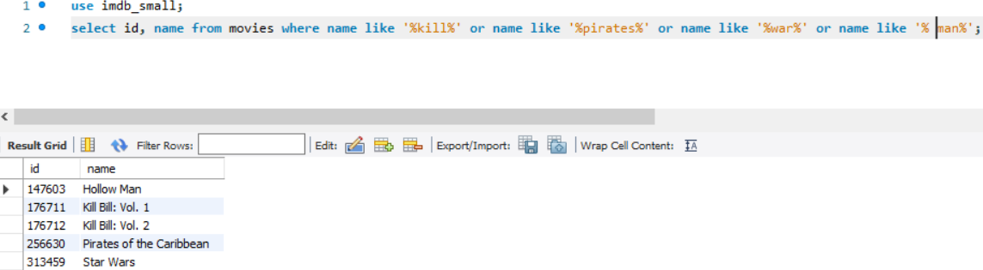

**3.** Title of films directed by Ethan Coen order by title.

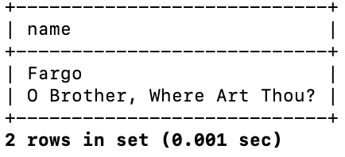

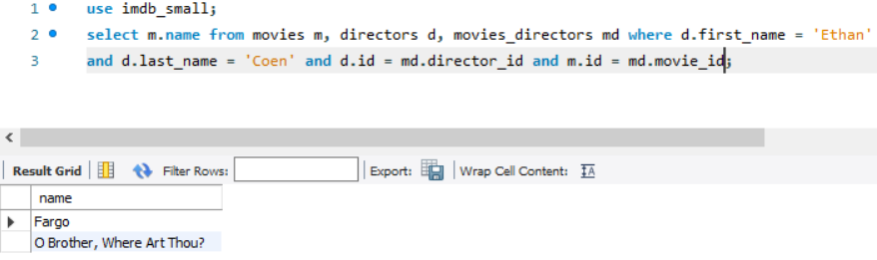

4. Title and year of premiere of the movies directed by Ethan Coen after 1996 order by year.

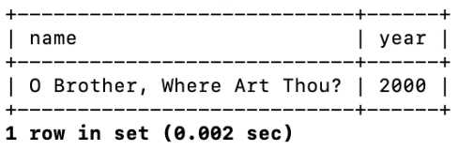

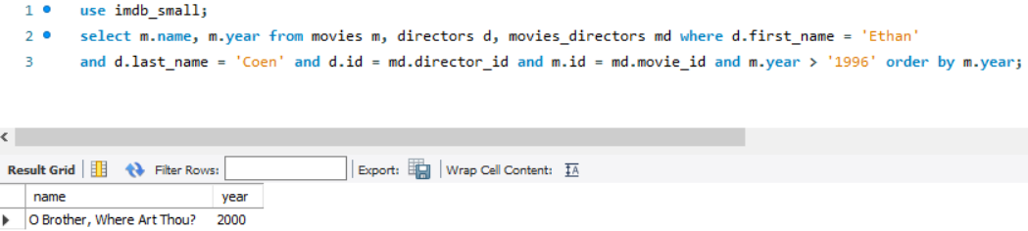

6. Name of the director, premiere year and full name and roles of the actors in the movie "Lost in Translation".

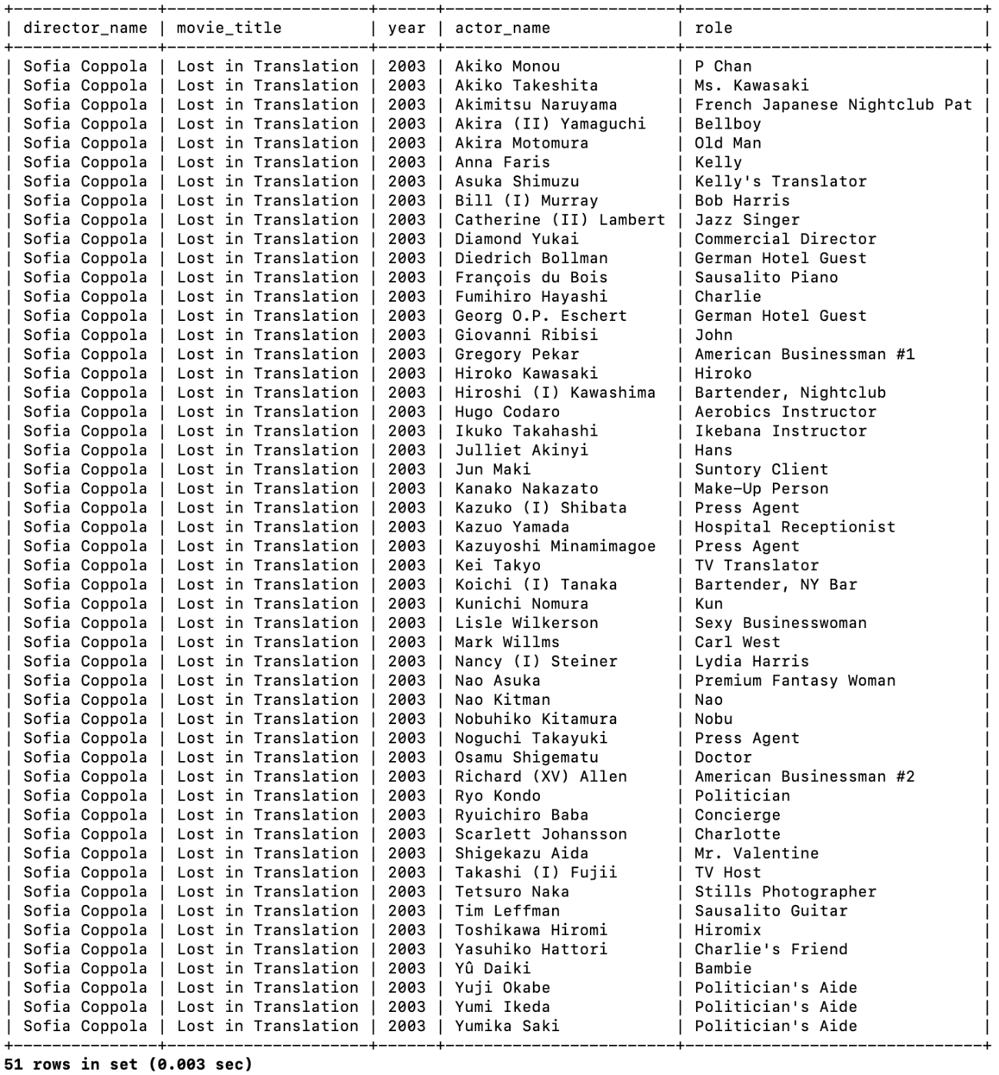

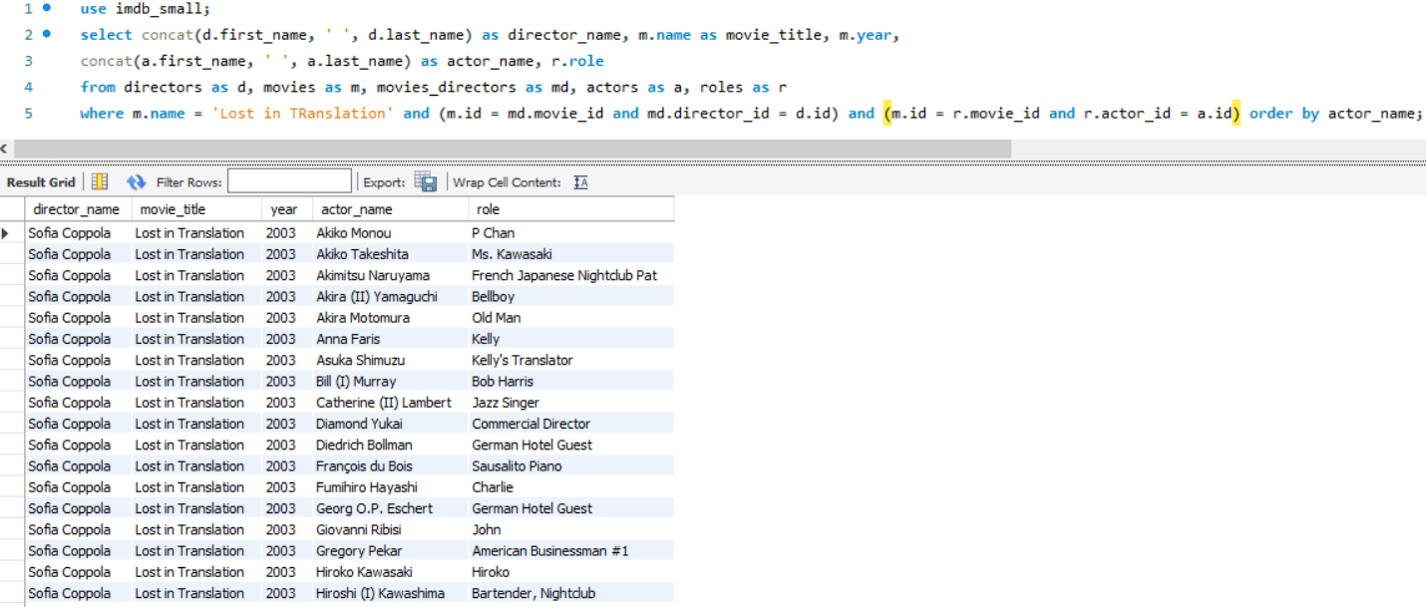

7. Title of the film, premiere year and full name of the director of all those films in which the director is also an actor in their own films. Sort the results by artist name.

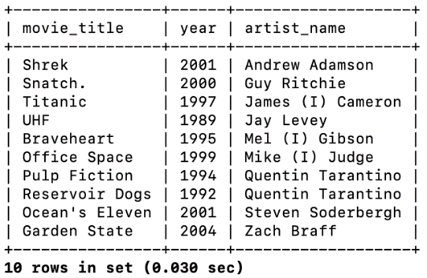

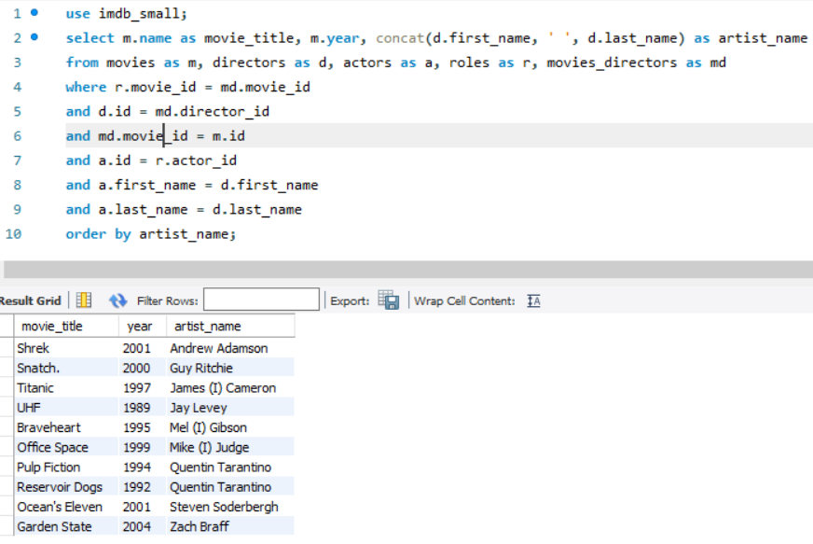

8. Name of the actors with whom Uma Thurman worked. Also indicate the full name and the year of the premiere of the film. Order the results by movie name and actor full name. Obviously, Uma Thurman must not be in the results.

|  |  |
| --- | --- |
|  |  |

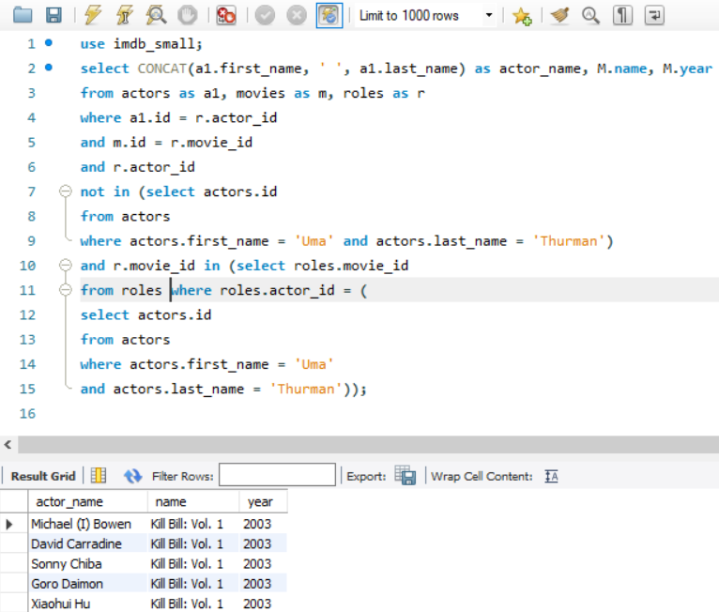

9. Name of the directors who have not been actors in their films, sorted by code.

Nombre de los directores que no han sido actores en sus películas, ordenados por código.

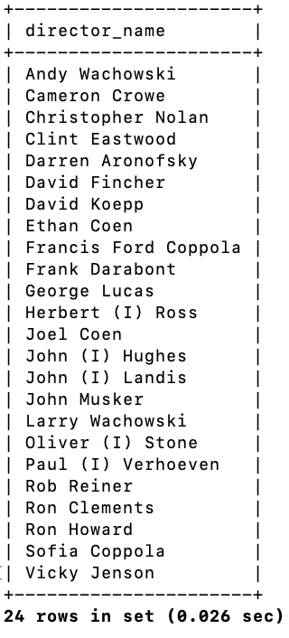

10. List of directors sorted by full name, indicating the number of films they have directed.

Lista de directores ordenados por nombre completo, indicando el número de películas que han dirigido.

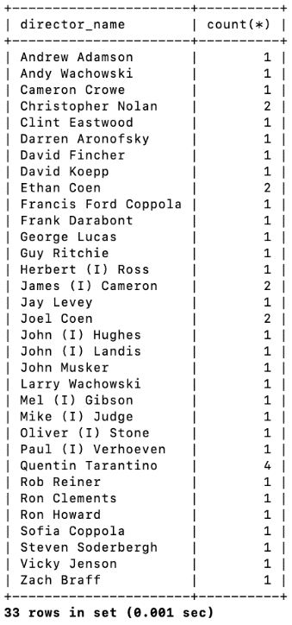

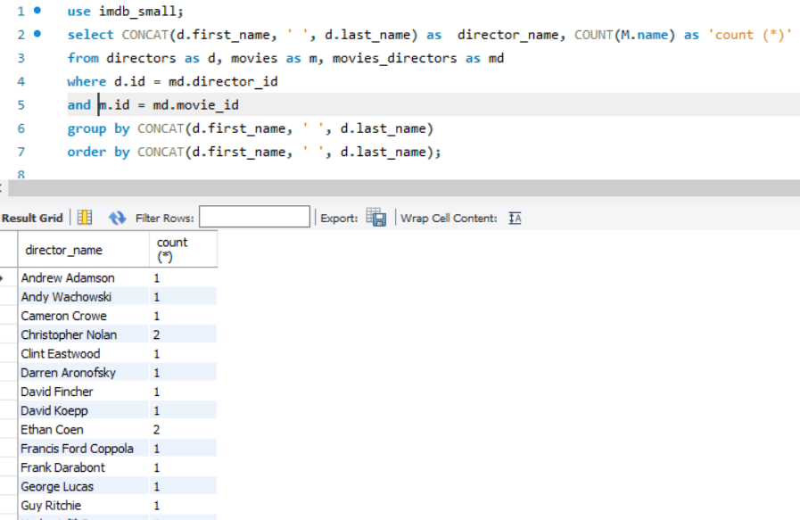

11. List of actors with surname starting with a ‘P’, indicating the number of films in which they have participated ordered by the number of films descendent.

Relación de actores cuyo apellido comienza con una "P", indicando el número de películas en las que han participado ordenados por el número de películas descendientes.

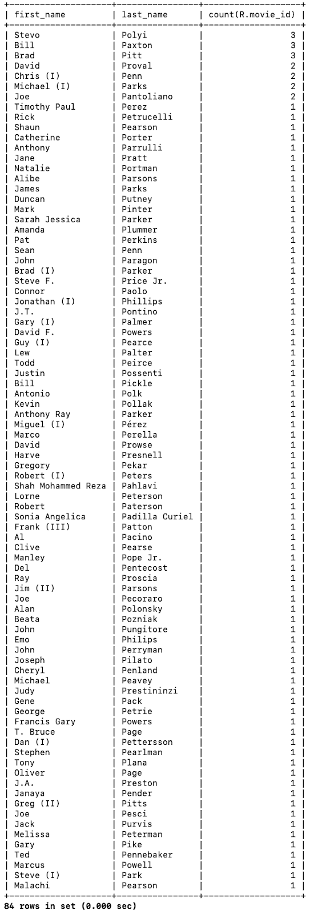

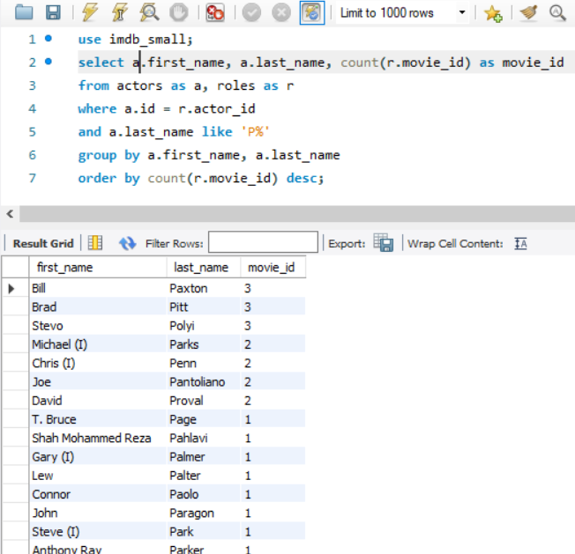

12. Do you think DIRECTORS and ACTORS should be the same table? Explain your answer.

No, porque aparte de que son cosas diferentes, un director también puede ser actor y viceversa.

13. Having DIRECTORS and ACTORS separated in two tables, can we have inconsistent data?

Sí puede haber datos inconsistentes, porque al tener directores que también son actores y viceversa, las dos tablas comparten datos y al actualizar los datos si lo actualizamos en la tabla de actores no se actualizaría automáticamente en la de directores.